The Metabolic Mirage: High FDG Avidity ($SUV_{max}$ 14) in Severe Radiation-Induced Hypothyroidism with Normal Ultrasound
Dr. Ajay Shukla¹, Dr. Gargi Tignath Shukla²
¹Department of Endocrinology, Max Super Speciality Hospital, Lucknow, Uttar Pradesh, India ²Associate Professor, Hind Institute of Medical Sciences, Barabanki, Uttar Pradesh, India
Address for correspondence: Dr. Ajay Shukla, Department of Endocrinology, Max Super Speciality Hospital, Lucknow, Uttar Pradesh, India. E-mail: dr.ajayshukla@gmail.com

Abstract
Introduction: Incidental thyroid uptake on 18F-FDG PET/CT poses a diagnostic dilemma. While focal uptake carries a high malignancy risk, diffuse uptake is generally benign. We report a rare case of intense diffuse uptake ($SUV_{max}$ 14.0) mimicking malignancy in a post-radiation patient.
Case Presentation: A 51-year-old female treated for carcinoma of the buccal mucosa (surgery and radiotherapy completed Feb 2025) presented with profound hypothyroidism ($TSH>100μIU/mL$) in Feb 2026. Review of records revealed she was treated with Propylthiouracil (PTU) for post-radiation thyrotoxicosis ($T4 24 mcg/dL$, $T3 256 ng/dL$), which was likely destructive in nature. A surveillance PET/CT revealed intense diffuse FDG avidity ($SUV_{max}$ 14.0), raising suspicion for metastasis or lymphoma. However, high-resolution ultrasound (USG) was benign, and TSH Receptor Antibodies (TRAb) were negative.
Discussion: The dissociation between high metabolic activity and normal structural integrity is explained by “First Principles”: massive TSH stimulation upregulates GLUT-1 glucose transporters on follicular cells, driving FDG uptake. This functional “overdrive” can mimic cancer.
Conclusion: In the presence of severe hypothyroidism, even high-grade diffuse FDG uptake is often physiological. Correlation with ultrasound is critical to avoid unnecessary biopsy.
Keywords: FDG PET/CT, Hypothyroidism, GLUT-1, Radiation Thyroiditis, Incidentaloma.

Introduction
The detection of thyroid incidentalomas on 18F-FDG PET/CT is increasingly common. The clinical approach typically dichotomizes findings into focal uptake (malignancy risk ~35%) and diffuse uptake (malignancy risk ~4%).[2]
However, diagnostic confusion arises when diffuse uptake presents with excessively high Standardized Uptake Values ($SUV_{max}>10$), a range typically associated with aggressive malignancies like Primary Thyroid Lymphoma or Anaplastic Carcinoma.[2] We present a case where physiological analysis—focusing on the effects of TSH on GLUT-1 transporters—prevented invasive workup in a post-cancer patient with an $SUV_{max}$ of 14.0.

Case Report
A 51-year-old female presented to the Endocrine clinic in February 2026 with fatigue and weight gain. She had a known history of Carcinoma of the Left Buccal Mucosa, managed with composite resection (Nov 2024) followed by 30 cycles of radiotherapy (completed Feb 08, 2025).
Drug History: Following radiotherapy, she was prescribed Propylthiouracil (PTU) 100 mg BD for 6 months by an outside physician for thyrotoxicosis. * Initial Reports (Post-RT): $TSH<0.001 μIU/mL$, Total $T4 24 mcg/dL$, Total $T3 256 ng/dL$. * Current Analysis: Retrospective calculation of the T3/T4 ratio (ng/mcg) yielded a value of 10.6, which typically indicates destructive thyroiditis rather than Graves’ disease ($>20$). PTU was stopped in May 2025.
Biochemical Evaluation (Feb 2026): * TSH: $>100 μIU/mL$ (Ref: 0.27–4.2) * Free T4: $0.97 ng/dL$ (Ref: 0.93–1.7) * Free T3: $0.2 pg/mL$ (Ref: 2.0–4.4) * TSH Receptor Antibody (TRAb): Negative (Ruling out Graves’ disease).
Imaging Findings (PET/CT - 30.01.2026): An 18F-FDG PET/CT was performed for oncological surveillance. * Head & Neck: Post-surgical changes with diffuse mucosal FDG avidity ($SUV_{max}$ 6.6) in the flap region. * Thyroid: Intense, diffuse FDG avidity was noted in both thyroid lobes with an $SUV_{max}$ of 14.0 (right lobe). * Structural: The CT component showed a morphologically normal thyroid gland.
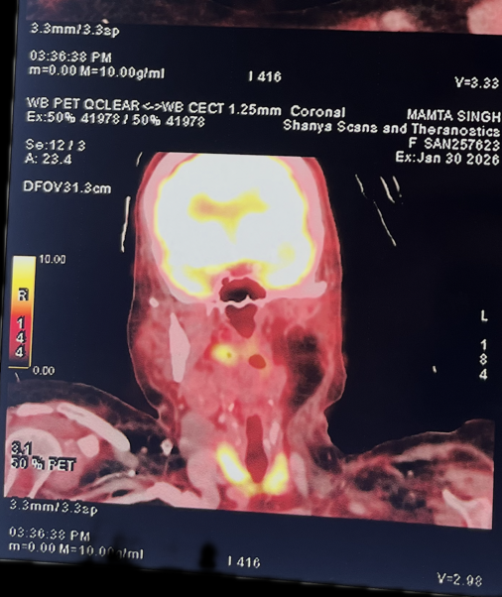
Figure 1A: Coronal Fused PET/CT showing intense diffuse FDG uptake in the thyroid gland ($SUV_{max}$ 14.0), mimicking malignancy.
Ultrasound Neck: Despite the history of radiation, the gland showed preserved volume and absence of focal nodularity on high-resolution imaging, ruling out a discrete mass or lymphoma.
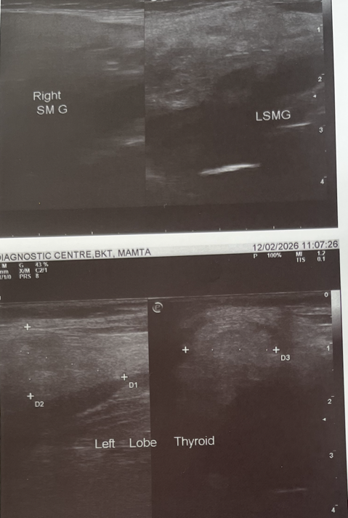
Figure 1B: High-Resolution Ultrasound of the Left Lobe showing normal echotexture and absence of nodules, ruling out structural malignancy.

Discussion
This case illustrates a “Physiological False Positive” driven by a perfect storm of Radiation Damage, PTU Suppression, and TSH Overdrive.

The Diagnostic Trap
An $SUV_{max}$ of 14.0 is alarmingly high. Karantanis et al. note that diffuse uptake is typically associated with autoimmune thyroiditis, but usually with lower intensity.[3] Haber et al. demonstrated that GLUT-1 expression (the driver of FDG uptake) is a marker of malignancy in 46% of thyroid cancers.[4] The absence of structural abnormalities on USG and the Negative TRAb were the pivot points against malignancy and Graves’ disease.

Retrospective Root Cause Analysis
The initial presentation was mismanaged with PTU. The initial T3/T4 ratio of 10.6 (256/24) strongly supports destructive radiation thyroiditis (leakage of preformed T4) rather than Graves’ disease (which favors T3 hypersecretion, ratio >20). The use of PTU likely accelerated the hypothyroid phase by blocking new hormone synthesis while the gland was already leaking.

First Principles: The GLUT-1 Mechanism
Why was the thyroid “glowing” without a tumor? 1. TSH Stimulation: TSH receptors on thyroid follicular cells utilize the cAMP pathway to upregulate GLUT-1 glucose transporters.[1] 2. The “Starving Cell” Hypothesis: The gland, damaged by radiation and previously blocked by PTU, was functionally failing. The pituitary responded with massive TSH secretion ($>100$). This forced the remaining viable thyrocytes to hyper-express GLUT-1 and avidly trap FDG to fuel hormone synthesis.[6]

Management
Recognizing this as a functional rather than pathological uptake, we initiated Levothyroxine replacement (1.6 mcg/kg). Biopsy was deferred. While chronic thyroiditis typically causes persistent low-grade uptake independent of TSH,[3] a significant reduction in the high-grade FDG avidity ($SUV_{max}$ 14) is expected after TSH normalization, confirming the functional “overdrive” component.

Conclusion
High-grade diffuse FDG uptake ($SUV_{max}>10$) in the thyroid does not always indicate malignancy. In the setting of severe hypothyroidism ($TSH>100$), it is often a marker of TSH-mediated GLUT-1 upregulation and a predictor of future thyroid dysfunction.[5] Clinicians must correlate PET findings with Ultrasound; if the USG is benign, treat the hypothyroidism and observe, rather than biopsy.

References
- Vera P, Kuhn-Lansoy C, Edet-Sanson A, et al. Does TSH trigger 18F-FDG uptake by the thyroid? Eur J Nucl Med Mol Imaging. 2014;41:126–127.
- Soelberg KK, Bonnema SJ, Brix TH, Hegedüs L. Risk of malignancy in thyroid incidentalomas detected by 18F-FDG PET: a systematic review. Thyroid. 2012;22(9):918-925.
- Karantanis D, Bogsrud TV, Wiseman GA, et al. Clinical significance of diffusely increased 18F-FDG uptake in the thyroid gland. J Nucl Med. 2007;48(6):896-901.
- Haber RS, Weiser KR, Pritsker A, Reder I, Burstein DE. GLUT1 glucose transporter expression in benign and malignant thyroid nodules. Thyroid. 1997;7(3):363-367.
- Kim YH, Chang Y, Kim Y, et al. Diffusely Increased 18F-FDG Uptake in the Thyroid Gland and Risk of Thyroid Dysfunction: A Cohort Study. J Clin Med. 2019;8(5):603.
- Gabriele E, Pellicori S, Romano L, et al. Thyroid uptake of 18F-FDG in patients with severe hypothyroidism. Endocrine. 2017;55:976–978.

